GAME IDEA 1: Game Design Brief
Concept:
Tumble is a Casual PC/Mobile game where the player controls a ball falling or Tumbling down a hill avoiding the hazards. The game will have about 15 levels each increasing in length and difficulty.

Game play:
A percentage counter will be included along with a high score display.
At the start of the game the ball spawns at the top of a themed hill and immediately starts falling down the hill.
The hazards (Fences, Shovels, etc) will reset the level and if necessary alter the high score
boost pads will increase speed for ramps but wont always be useful
ramps will be included as of level 3 and will require a certain amount of speed to be useful
At the end of the level the ball will be shot off a ramp with a fire works particle display
Core Mechanics:
single player
simple controls
speed boost on boost pads
level reset when a hazard is hit
ramps have a speed requirement

Minor Mechanics/Logic:
3rd person perspective
the scores need to be recorded (after the game is closed if possible)
unique music for each level

Out of scope mechanics:
different themes for different levels
pause and menu screens
save score after the game is over if possible
Inspirations/similar works:
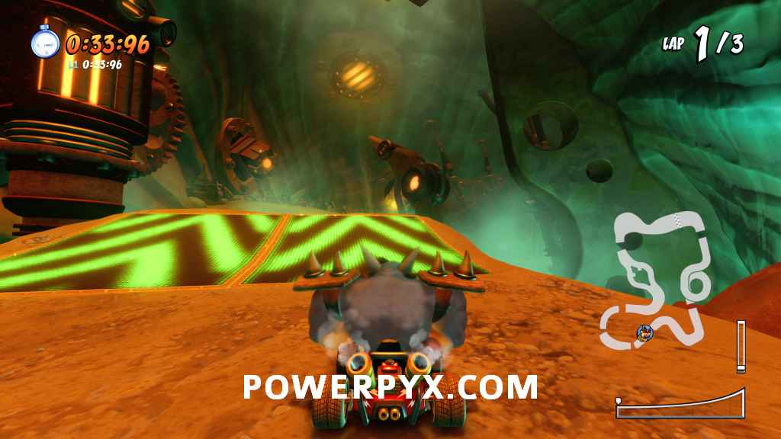
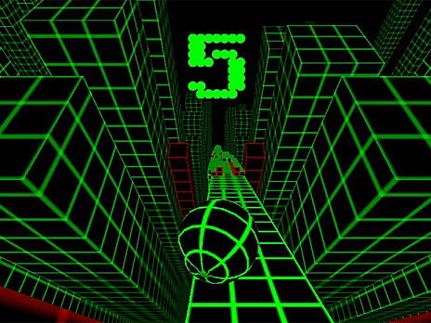


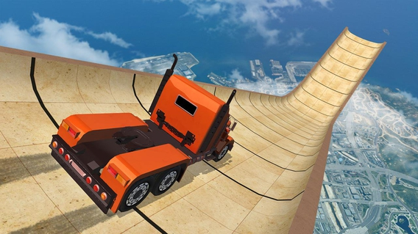

Development challenges:
I see some problems with speed requirements on ramps for the game
I also see problems with saving the score after the game has closed
I also dont know how to program a fair amount of the features included

